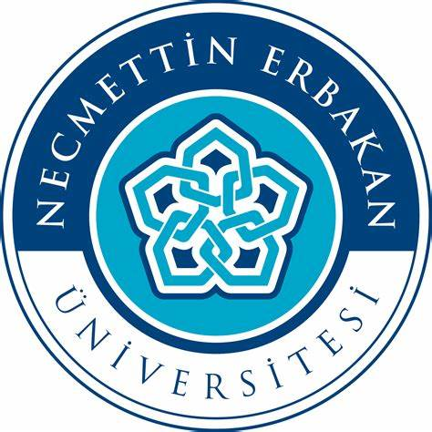

MEMORANDUM OF UNDERSTANDING
BETWEEN
UNIVERSITY OF DARUSSALAM GONTOR
INDONESIA
AND
.
.
.
.
..
NECMETTIN ERBEKAN UNIVERSITESI
MALAYSIA

This Memorandum of Understanding (hereinafter referred to as MoU) is made on this October … ,2021, located at Necmettin Erbekan Universitesi
BETWEEN
UNIVERSITY OF DARUSSALAM GONTOR (hereinafter referred to as “UNIDAGontor”), whose address is at Jl. Raya Siman Km. 6, Ponorogo, East Java, 64371, Indonesia represented herein by its Rector, Prof. Dr. Hamid Fahmy Zarkasyi, M.A.Ed., M.Phil;
AND
.
.
..
.
.

NECMETTIN ERBEKAN UNIVERSITESI (hereinafter referred to as “UNIDAGontor”), whose address is Yeni Meram Boulevard Kasım Halife Street No: 11/1 (Block A) No: 11 (Block B) Post Code: 42090 Meram / KONYA, represented herein by its Rector, Prof. Dr. Cem ZORLU;
hereinafterreferred to singularly as “the Party” and collective as the “Parties”, wishing to establish relations between the two institutions, agree to cooperate with each other as follows:
Article 1
Objective
The parties, subject of the terms of this MoU and the laws, rules, regulations and national policies from the time in force in each Party’s country, will endeavor to strengthen, promote and develop cooperation between the parties on the basic of equality and mutual benefit in the areas of common interests.

Article 2
General Areas of Co-operation
- Cooperation shall be carried out through such activities as:
- Promote individual contact, link in teaching, research, and publication activities among scholar, student and personnel of both institutions;
- Exchange of faculty and/or students for undergraduate and postgraduate studies;
- Exchange of academic and research staff;
- Joint academic and research program, and publications;
- Join seminars, workshop, academic meetingsand training programs;
- Join education programs;
- Cooperation in other areas as mutually agreed by the parties.

- The terms of cooperation for each specific activity implemented under this MoU shall be mutually discussed and agreed upon in a separate written binding agreements by both parties prior to the initiation of that activity PROVIDED ALWAYS the decision whether to initiate and/or implement any activity prior to entering into the separate written agreement shall be at the sole discretion of each Party.
Article 3
Financial Arrangements
This MoU will not give rise to any financial obligation by one party to the other, each party will bear its own cost and expenses in relation to this Memorandum of Understanding;
Article 4
Confidentiality
(1) The Parties agree and undertake to keep confidential at all times any information or data that may be exchanged, acquired or shared in connection with any activity conducted pursuant to this MoU.

(2) The obligation of confidentiality contained in this MoU shall not apply to any Confidential Information which:
a. has been made public by the Disclosing Party or by others with the permission of the Disclosing Party;
b. is independently received from a third party who is free to disclose it;
c. is in the public domain or is a compilation of material in the public domain.

Article 5
Duration And Termination
(1) This MoU shall take effect from the last signature date on this MoU and shall continue to be effective for a period of five (5) years and may be extended for such further period as may be agreed by the Parties in writing.

(2) Notwithstanding Article 5 (1) above, this MoU may be terminated by either party giving written notice to the other at least six (6) months prior to the proposed date of termination.

(3) Notwithstanding Article 5 (2) above, the provisions of this MoU or any other written agreement in respect of any on-going exchange or other form of cooperative activity under this MoU shall continue to apply until their completion unless both Parties mutually agree in writing to the earlier termination of the cooperative activity.

Article 6
Any such agreements entered into, as outlined above, will form appendices to this MoU. Each institution shall designate a liaison officer to develop and coordinate the specific activities agree upon.
The designated liaison officers for this MoU are:

For  Necmettin Erbekan Universitesi  Prof. Dr. Cem ZORLU  Rector | For  University of Darussalam Gontor  Prof. Dr. Hamid Fahmy Zarkasyi, M.A.Ed., M.Phil  Rector
Yeni Meram Boulevard Kasım Halife Street No: 11/1 (Block A) No: 11 (Block B) Post Code: 42090 Meram / KONYA,  Tel: 0332 221 05 00  Deputy Director, Academy of Islamic Studies,  Tel:  50603 Kuala Lumpur, Wilayah Persekutuan Kuala Lumpur  MALAYSIA | Jl. Raya Siman Km.6, Ponorogo, East Java,63471  INDONESIA  rektorat@unida.gontor.ac.id  +62 352 483762

Notification of any change in liaison officers may be made by letter without amending this Memorandum of Understanding.
Article 7
Settlement of Disputes
Any difference or dispute between the Parties concerning the interpretation and/ or implementation and/or application of any of the provisions of this MoU shall be settled amicably through mutual consultation and/or negotiations between the Parties through diplomatic channels, without reference to any third party or international tribunal.

Article 8
Miscellaneous
(1) This MoU may be modified, varied or amended at any time after due to consultation and with the written agreement of both Parties.

(2) The use of the name, logo and/or official emblem of any of the Parties on any publication, document and/or paper is prohibited without the prior written approval of either Party.
(3) This MoU is not intended to be legally binding. It merely expresses the intentions and understanding of the Parties which will form the basis of anylegally binding agreement to be drafted and executed in the future.
(4) The Parties hereby agree that they are not bound exclusively by this MoU and shall be at liberty to enter into any separate agreements or arrangements with any third party without reference to the other Party.
In witness whereof, the Parties here to have offered their signatures:
ForUniversity of Malaya  Malaysia | For University of Darussalam Gontor  Indonesia
Prof. Datuk Dr. RohanaYusof | Prof. Dr. Amal Fathullah Zarkasyi, M.A.
Deputy Vice-Chancellor (Student Affairs and  Alumni) | Rector
Witnessed by | Witnessed by
__________________________________________________  Prof. Dr. Stefanie ShamilaPillai | _____________________________________________  M. TaufiqAffandi, M.Sc..
Dean, Faculty of Language & Linguistics | Secretary of Rector
Date: October 19, 2017 | Date:October 19, 2017

