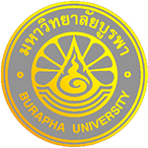
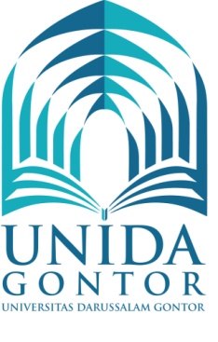

MEMORANDUM OF UNDERSTANDING
between
UNIVERSITY OF DARUSSALAM GONTOR (INDONESIA)
and
BURAPHA UNIVERSITY (THAILAND)

University of Darussalam Gontor (UNIDA Gontor), and Burapha University (Thailand), wishing to establish relations between the two institutions, agree to cooperate with each other as follows:
Scope of the Cooperation
Subject to mutual consent, the areas of cooperation will include any program offered at either institution as thought desirable and feasible by either party and that all parties think will contribute to the fostering and development of the cooperative relationship between the two institutions.
Cooperation shall be carried out through such activities as:
- Exchange of faculty and/or students
- Joint research activities and publications
- Participation in seminars and academic meetings
- Exchange of academic materials and other information
- Special short-term language and academic programs
The terms of cooperation for each specific activity implemented under this Memorandum of Understanding shall be mutually discussed and agreed upon in writing by both parties prior to the initiation of that activity.
Any such agreements entered into, as outlined above, will form appendices to this Memorandum of Understanding. Each institution shall designate a liaison officer to develop and coordinate the specific activities agree upon.

The designated liaison officers for this Memorandum of Understanding are:

For  Burapha University (Thailand)  Dr. Nawasit Rakbamrung  Assitant President Global Relation Center Burapha University | For  University of Darussalam Gontor  Prof. Dr. Amal Fathullah Zarkasyi, M.A.  Rector
169 Long-Hard Bangsaen Road, Saen Sook Sub-district, Mueang District, Chonburi 20131  nawasit@buu.ac.th  +66 (0)38 102 907 | Jl. Raya Siman Km.6 Ponorogo, East Java,  INDONESIA  rektorat@unida.gontor.ac.id  +62 352 483762

Notification of any change in liaison officers may be made by letter without amending this Memorandum of Understanding.

Renewal, Termination and Amendment
This Memorandum of Understanding shall remain in force for a period of five (5) years from the date of the last signature, with the understanding that it may be terminated by the appropriate authorities of either party giving twelve months notice to the other party in writing, unless an earlier termination date is mutually agreed upon. The Memorandum of Understanding may be amended of extended by mutual written consent of the two parties.

In witness whereof, the parties here to have offered their signatures:

For Burapha University (Thailand) | For University of Darussalam Gontor  (Indonesia)
Dr. Nawasit Rakbamrung | Prof. Amal Fathullah Zarkasyi, M.A.
Assitant President Global Relation Center Burapha University | Rector

Date: February …...., 2017 Date: February ……, 2017

